2.b eng 6.4.- 10.4.

* **PONAVLJANJE**
* **DAYS OF THE WEEK**
* Ponovi dane u tjednu (Days of the week) kao brojalicu i riješi listić na kraju stranice. Pogledaj sličice. Koji je dan i što djeca rade? (What day is it? What are children doing?) Odaberi tri dana- sličice i rečenice napiši u bilježnicu.
* Ako postoji mogućnost printanja- ovaj je listić (s dodatnim zadacima za vježbanje) na kraju stranice, pa ga isprintaj, riješi i zalijepi u bilježnicu.

WHAT ARE THEY DOING? - days of the week

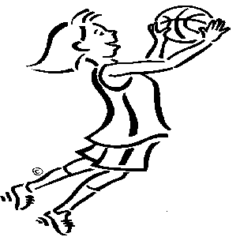 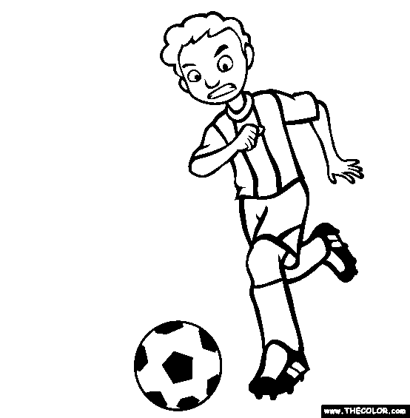 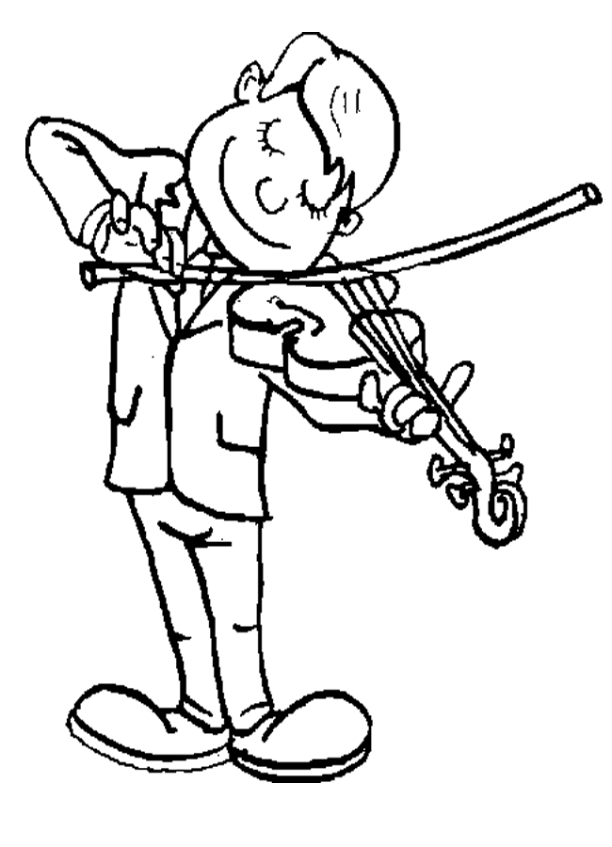 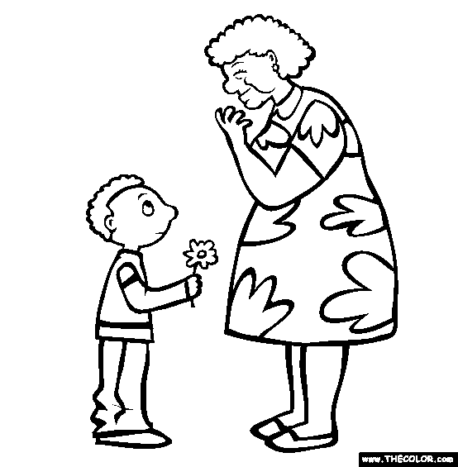

Monday Tuesday Wednesday Thursday

 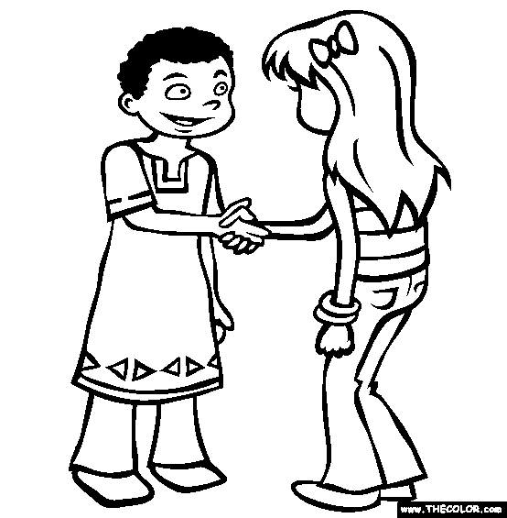 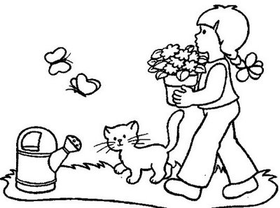

Friday Saturday Sunday

* It’s __________________. Anne is meeting her best friend.
* It’s Friday . David ____________.
* It’s __________________. Kate is playing basketball.
* It’s __________________. Adam is playing violin.
* It’s __________________. Mary is working in the garden.
* It’s __________________. Michael is visiting his granny.
* It’s Tuesday . Paul is playing football.
* **CLOTHES**
* Na sljedećoj poveznici ponovi odjevne predmete.

Clothes- yes/no : <https://wordwall.net/play/512/292/224>

* Pokušaj izreći na engleskom koje odjevne predmete ti i tvoji ukućani danas imate na sebi.

(Npr.: I, ve got a red t- shirt, and yellow socks. My mum has got blue jeans and purple trainers.)

* **TRACY'S CLOTHES and LUKE'S CLOTHES (HER/ HIS)**

1. Otvori udžbenik na stranici 63 i 64, pogledaj sličice i odgovori:

What is Tracy packing in her suitcase? What is Luke packing in his suitcase?

What colour is HER mask? What colour is HIS cap?

What colour are HER sandals? What colour are HIS jeans?

Pogledaj, što je u pitanjima drugačije? Kada koristimo HER a kada HIS? Kada koristimo IS a kada ARE?

* Tracy je djevojčica, a znamo da se za sve osobe ženskog roda kaže *ona*- na engleskom SHE.

Nešto što ona ima je *njezino*- na engleskom HER.

This is Tracy. SHE is a girl. HER T- shirt is blue.

Ovo je Tracy. ONA je djevojčica. NJEZINA majica je plava.

* Luke je dječak, a znamo da se za sve osobe muškog roda kaže *on*- na engleskom HE.

Nešto što on ima je *njegovo*- na engleskom HIS.

This is Luke. HE is a boy. HIS jacket is yellow.

Ovo je Luke. ON je dječak. NJEGOVA jakna je žuta.

Kada pričamo o *jednoj stvari* koristimo IS….a cap IS yellow, a jacket is violet….

Kada pričamo o *dvije i više* stvari koristimo ARE…..

U slučaju odjevnih predmeta- za sve što nosimo na nogama, rukama, tj. dolazi u paru koristimo ARE….sandals ARE orange, trainers ARE brown (pa tako i hlače…jeans, shorts 😊)

1. Otvori bilježnicu i napiši naslov *Tracy's clothes and Luke's clothes*

Nacrtaj djevojčicu i dječaka i ispod njih napiši

 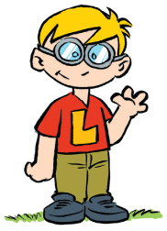

SHE- ona HE- on

HER- njezino HIS- njegovo

1. Iz udžbenika na stranicama 64 i 65, iz zadataka 7) i 9) u bilježnicu prepiši po 2 rečenice.
2. Riješi zadatke u radnoj bilježnici na stranicama 67 i 68.
3. Dodatni zadaci za vježbanje SHE/ HER i HE/HIS su na kraju ovog dokumenta.

* **EASTER TIME**
* Na sljedećim poveznicama pronaći ćeš aktivnosti vezane za blagdan koji nam dolazi, Uskrs :
* Riječi, pojmove, sličice

Riječi poslušaj, izgovoriti, a neke potom nacrtati i napisati u svoju bilježnicu

<https://www.youtube.com/watch?v=7yx2xIpNiQ4>

<https://quizlet.com/500250413/easter-flash-cards/?x=1qqt>

<https://learnenglishkids.britishcouncil.org/flashcards/easter-flashcards>

* U udžbeniku na stranici 91 je prigodna pjesmica. Poslušaj CD (snimka br. 65 )

i odglumi što čuješ te odgovori na pitanja u 3. zadatku. Listen and mime, do the exercise 3).

U radnoj bilježnici, na stranici 95 oboji sliku. Colour the picture in your activity book on the page 95.

* **DODATNE AKTIVNOSTI (u nastavku):**

1. Listići (za printanje)
2. Poveznice

* Prigodne igrice

<https://learnenglishkids.britishcouncil.org/word-games/easter>

* Story Egg hunt

<https://learnenglishkids.britishcouncil.org/speak/the-great-egg-hunt>

WHAT ARE THEY DOING? - days of the week

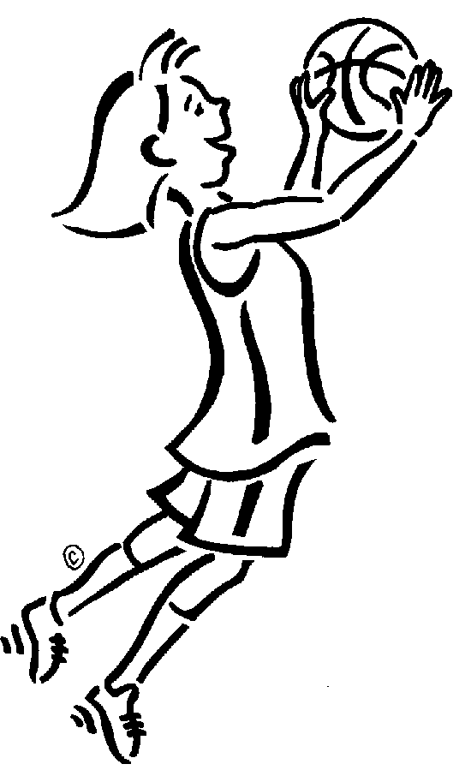   

Monday Tuesday Wednesday Thursday

  

Friday Saturday Sunday

* It’s __________________. Anne is meeting her best friend.
* It’s __________________ .David is swimming.
* It’s __________________. Kate is playing basketball.
* It’s __________________. Adam is playing violin.
* It’s __________________. Mary is working in the garden.
* It’s __________________. Michael is visiting his granny.
* It’s __________________. Paul is playing football.

Now, write about yourself and your family ( napiši što ti i članovi tvoje obitelji radite):

It’s Monday. __________________________________________

It’s Tuesday. __________________________________________

It’s Wednesday. _______________________________________

It’s Thursday. _________________________________________

It’s Friday. ___________________________________________

It’s Saturday. _________________________________________

It’s Sunday. __________________________________________

Today is __________________________.

Draw what you and your family are doing today:

**He/ His She/Her**

1. Write (napiši):

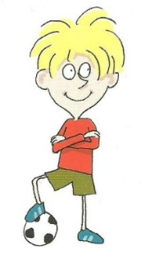He / His She /Her

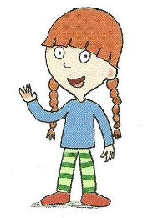

This is Jessica. This is Greg.  
______ is a girl. _______ is a boy.  
______ likes ice-cream. _______ likes football.

______ T- shirt is blue. _______ shorts are green.  
______ has got a red hair. _______ has got a ball.

1. Draw a boy and a girl and write 4 sentences for a boy and 4 sentences for a girl. Use he/his and she/her. Nacrtaj jednog prijatelja (dječaka) i jednu prijateljicu (djevojčicu) i za svakoga napiši 4 rečenice koristeći he/his i she /her. Kao u 1 zadatku.
2. **_____________________________ 1.______________________________**
3. **_____________________________ 2.______________________________**
4. **_____________________________ 3. ______________________________**
5. **_____________________________ 4. ______________________________**

**CLOTHES AND COLOURS**

Read and colour.

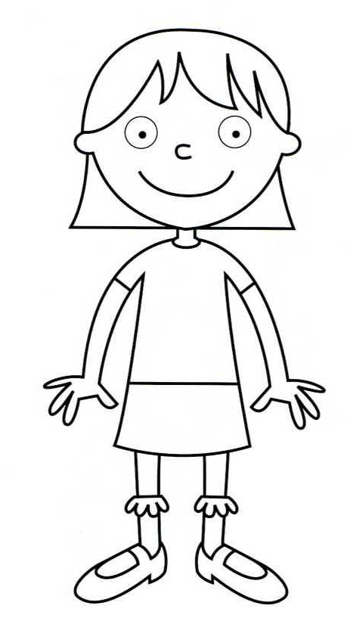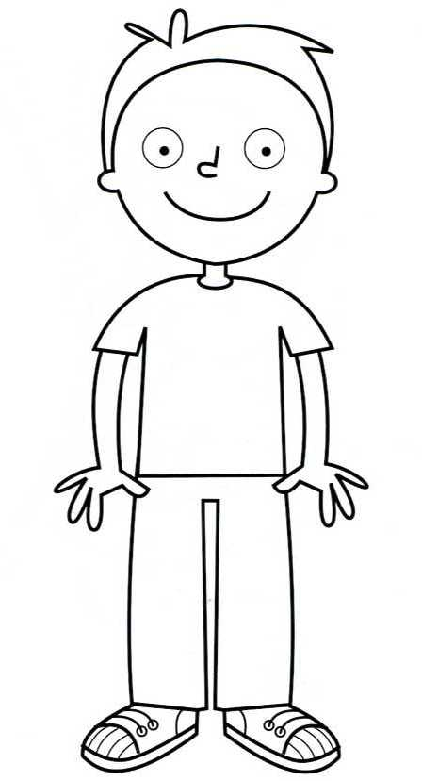

His hair is brown.

His eyes are blue.

His trainers are purple and yellow.

His T-shirt is blue.

His jeans are red.

Her hair is blonde.

Her t-shirt is pink.

Her eyes are green.

Her skirt is purple.

Her socks are orange.

Her shoes are yellow.