2.b ENG ( 18.5- 22.5.)
DIP IN 2
UNIT 4: WHAT CAN THEY DO?
LESSON 1: MYSTERIOUS MIKE- ponavljanje
JOBS

- DIO- MYSTERIOUS MIKE- ponvljanje
MYSTERIOUS MIKE
- Kako bismo ponovili priču o detektivu Mike- u, još jednom pogledajte i poslušajte priču na sljedećoj poveznici:
Mysterious Mike: https://m.youtube.com/watch?v=c0omon1x8R0&feature=youtu.be
- Poslušajte zvučni zapis 51 na CD-u ili na linku:
https://www.e-sfera.hr/dodatni-digitalni-sadrzaji/c7a5e56e-78d2-4510-b440-e5be7f836f74/
- Pročitajte tekst još jednom. Pazite na izgovor riječi.
Pjesmica
- Poslušajte (tonski zapis 52 i 53 ili na poveznici: https://www.e-sfera.hr/dodatni-digitalni-sadrzaji/c7a5e56e-78d2-4510-b440-e5be7f836f74/) i pokretima pokazujte što čujete. Nekoliko puta pročitajte pjesmicu, a zatim u ritmu pokušajte i otpjevati uz “detektivsku koreografiju”.

- Opišite detektiva kojeg ste prošli puta nacrtali u svoje bilježnice. What can he/ she do?

Da biste ponovili naučeno, odigrajte igrice:
https://wordwall.net/play/517/080/242
https://quizlet.com/507661792/mysterious-mike-flash-cards/
https://www.bookwidgets.com/play/WVBSWV?teacher_id=4926208725745664

-Razmisli što ti znaš/ možeš i odgovori sa Yes, I can. ili No, I can’t.
- Can you fly? Can you dance? Can you make a sandwich? Can you drive a car?
Yes, I can. No, I can’t.
U bilježnicu napiši nekoliko rečenica o sebi (možeš se i nacrtati):
I can __________________. I can’t ______________________.
I can __________________. I can’t ______________________.

- DIO- JOBS_________________________
Otvorite radnu bilježnicu na stranici 81. Što vidite? Tko si ovi ljudi? Što oni rade?
Poslušajte zvučni zapis na CDu, br. 54. Upišite brojeve pored slika. Pročitajte tekst.

- Pronađite riječi u tekstu:
a pie - pita
a baker - pekar
a firefighter - vatrogasac
a mechanic - mehaničar
an astronaut – astronaut

- U bilježnicu napišite naslov JOBS (zanimanja/ poslovi), riječi koje ste pronašli prepišite u bilježnicu, prevedite ih i pokušajte nacrtati kako biste ih bolje upamtili.

- U radnoj bilježnici, na stranici 82. riješite zadatak 6. Pronađite parove.
U zadatku 7 odgonetnite riječi i napišite ih na prazne crte.
Nacrtajte što želite biti kad odrastete u zadatku 8. What can you do?

Dodatni sadržaj: Busy pad 2: riješite stranice 49 i 50 kako bi uspješnije savladali gradivo.
- Kako biste ponovili ova zanimanja i naučili neka nova, odigrajte igrice:
https://wordwall.net/play/473/483/631
https://wordwall.net/resource/1503925/engleski-jezik/jobs

Dodatni listići za vježbu
(ukoliko postoji mogućnost printanja, zamolite roditelje da vam ove listiće isprintaju. Vi ich riješite i zalijepite u bilježnicu. Ukoliko mogućnost printanja ne postoji, odaberite par zadataka koje ćete prepisati i riješiti u bilježnicu.)

CAN/CAN'T & ACTIVITIES

Match two parts of a sentence (Spoji dva dijela rečenice)

1 A fish |  |  | can hop.
2 A frog |  |  | can dance.
3 A bird |  |  | can crawl.
4 A chimp |  |  | can run.
5 A rabbit |  |  | can sing.
6 A snake |  |  | can swim.
7 A cat |  |  | can fly.
8 A parrot |  |  | can jump.
9 A horse |  |  | can climb.

Write the sentences (Napiši te rečenice)
1 A fish ___________________________ .
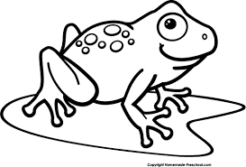
2 A frog ___________________________ .
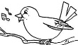
3 A _______________________________.
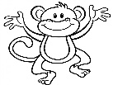
4 A _______________________________.
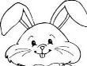
5 A _______________________________.
6 A _______________________________.
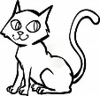
7 A _______________________________.
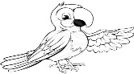
8 A _______________________________.
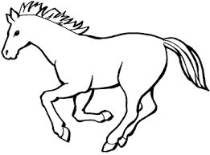
9 A _______________________________.

Complete the sentences (Dovrši rečenice)

1 I can ___________________________________________

2 I can't __________________________________________

1) Write. Napiši.

dive, robber, plane, car, motorbike, rock, rope.

Fly a ___________________________________________.

Ride a ___________________________________________.

Catch a __________________________________________.

Climb a __________________________________________.

Walk on a ________________________________________.

Drive a ___________________________________________.

Roniti. ____________________________________________.

2) Complete with (dopuni sa): CAN or CAN'T.
1) A bird _____________________ crawl.
2) A snake ___________________ fly.
3) A cat _____________________ climb.
4) A dog ____________________ sing.
5) A horse __________________ run.
6) A rabbit __________________ hop.
7) A frog ____________________ swim.
8) A bird ____________________ sing.
9) A chimp ___________________ dance.
10) A frog ____________________ jump.

3) Odgovori:

Ask and answer: Can you … ?
Write

- Can you ………………………………………? Yes, I can No, I can’t.

- Can you ………………………………………? Yes, I can. No, I can’t.

- Can you ………………………………………? Yes, I can. No, I can’t.

- Can you ………………………………………? Yes, I can. No, I can’t.

Hi.
- Can you ………………………………………? Yes, I can. No, I can’t.

- Can you ………………………………………? Yes, I can. No, I can’t.

- Can you ………………………………………? Yes, I can. No, I can’t.

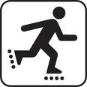
- Can you ………………………………………? Yes, I can. No, I can’t.

- Can you ………………………………………? Yes, I can. No, I can’t.

10. Can you ……………………………………? Yes, I can. No, I can’t.

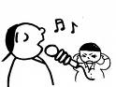

11. Can you ………………………………………? Yes, I can. No, I can’t.

12. Can you ………………………………? Yes, I can. No, I can’t.

Word bank
cook – dance - play the guitar - play the piano - play tennis -
ride a bicycle - ride a horse – sing – skate - skip - speak English - swim

